**Aim -**

To study and Implement Platform as a Service using AWS Elastic Beanstalk Service.

**Theory -**

Platform as a Service (PaaS) is a cloud computing service model that provides a platform allowing customers to develop, run, and manage applications without the complexity of building and maintaining the infrastructure typically associated with developing and launching an application. In PaaS, the cloud service provider manages the underlying infrastructure, including hardware, operating systems, middleware, runtime environments, and networking, while users focus on building and deploying their applications.

Advantages of Platform as a Service (PaaS):

* Faster Time to Market: PaaS provides developers with pre-configured development environments and tools, allowing them to quickly build and deploy applications without the need for manual setup and configuration. This accelerates the development lifecycle, enabling faster time to market for new applications and features.
* Cost Efficiency: PaaS follows a pay-as-you-go pricing model, where users only pay for the resources and services they consume. This eliminates the need for upfront investment in hardware and infrastructure, reducing capital expenditure and enabling cost-effective scaling based on demand.
* Scalability and Elasticity: PaaS platforms offer scalability features that allow applications to easily scale up or down based on demand. This elasticity enables organizations to accommodate fluctuating workloads and ensures optimal performance and resource utilization without the need for manual intervention.
* Reduced Management Overhead: PaaS abstracts the complexity of managing underlying infrastructure, including hardware provisioning, software installation, patching, and maintenance. This reduces administrative overhead and allows organizations to focus on application development and innovation rather than infrastructure management.
* Built-in Services and Integrations: PaaS platforms often provide a wide range of built-in services, such as databases, messaging queues, caching, authentication, and monitoring, which can be easily integrated into applications. This simplifies development and reduces the need for third-party services and integrations.

Disadvantages of Platform as a Service (PaaS):

* Vendor Lock-In: Adopting a PaaS platform may lead to vendor lock-in, as migrating applications and data between different PaaS providers or transitioning from PaaS to an on-premises deployment can be complex and costly. Organizations should carefully evaluate the long-term implications of vendor lock-in and consider strategies to mitigate this risk.
* Limited Control and Customization: PaaS abstracts the underlying infrastructure from users, limiting their control and customization options. Organizations with specific security, compliance, or performance requirements may find the level of control offered by PaaS platforms insufficient for their needs.
* Dependency on Internet Connectivity: PaaS relies on internet connectivity for accessing and managing development and deployment resources, which may pose challenges in environments with limited or unreliable internet connectivity. Organizations should consider the potential impact of internet outages or disruptions on their development and deployment processes.
* Security and Compliance Concerns: Storing sensitive data and running applications in a third-party cloud environment raises concerns about data security and compliance. Organizations must carefully evaluate the security measures implemented by PaaS providers to ensure compliance with regulatory requirements and protect their data from unauthorized access and breaches.
* Performance and Latency: Performance and latency issues may arise in PaaS environments, particularly in multi-tenant deployments where resources are shared among multiple users. Organizations should assess the performance characteristics of PaaS offerings and ensure they meet their performance requirements before migration.

**Procedure -**

Step1 : Login to AWS console and go to Elastic Beanstalk

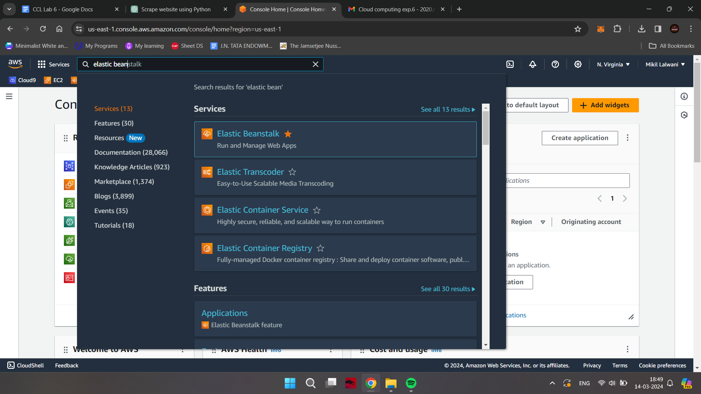

Step 2: Click on Create Application

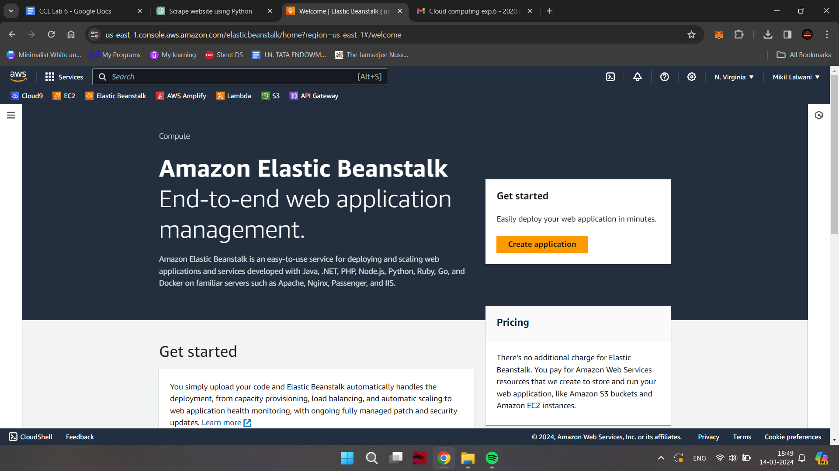

Step 3: Write Application information : Name, Tag,Platform etc.

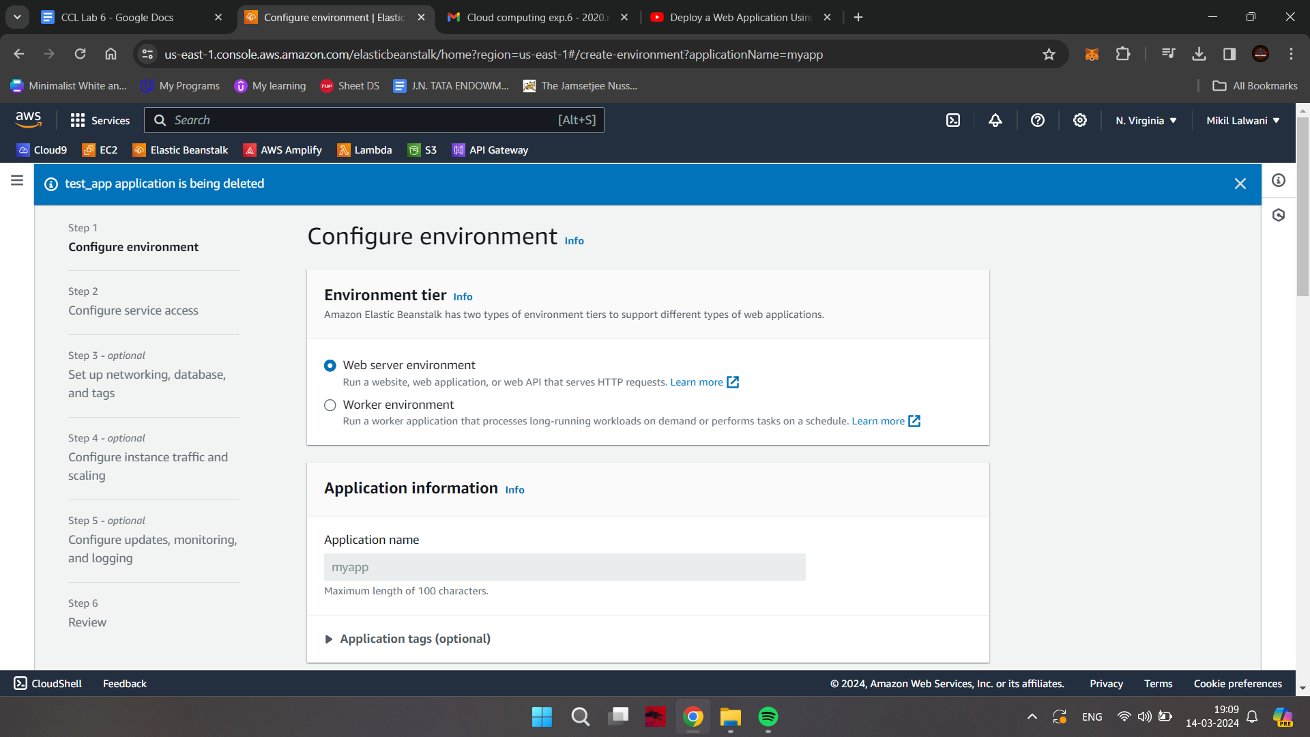

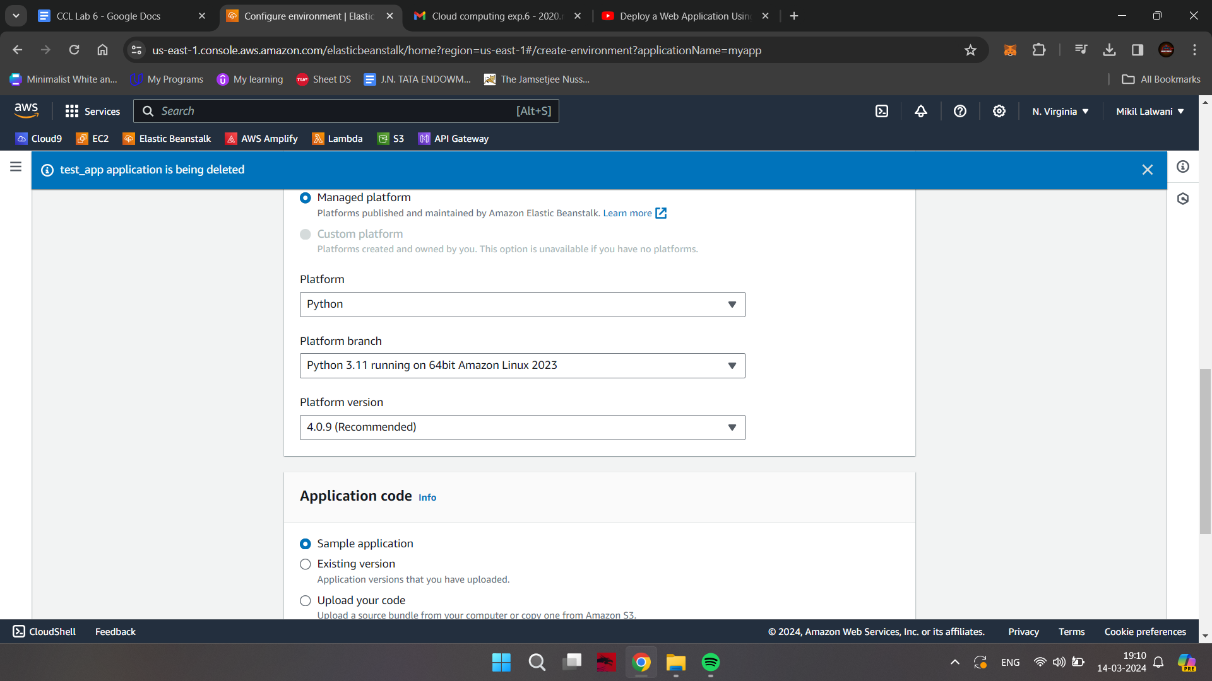

Step 4: In Application Code: select sample application and then Click on button Create Application

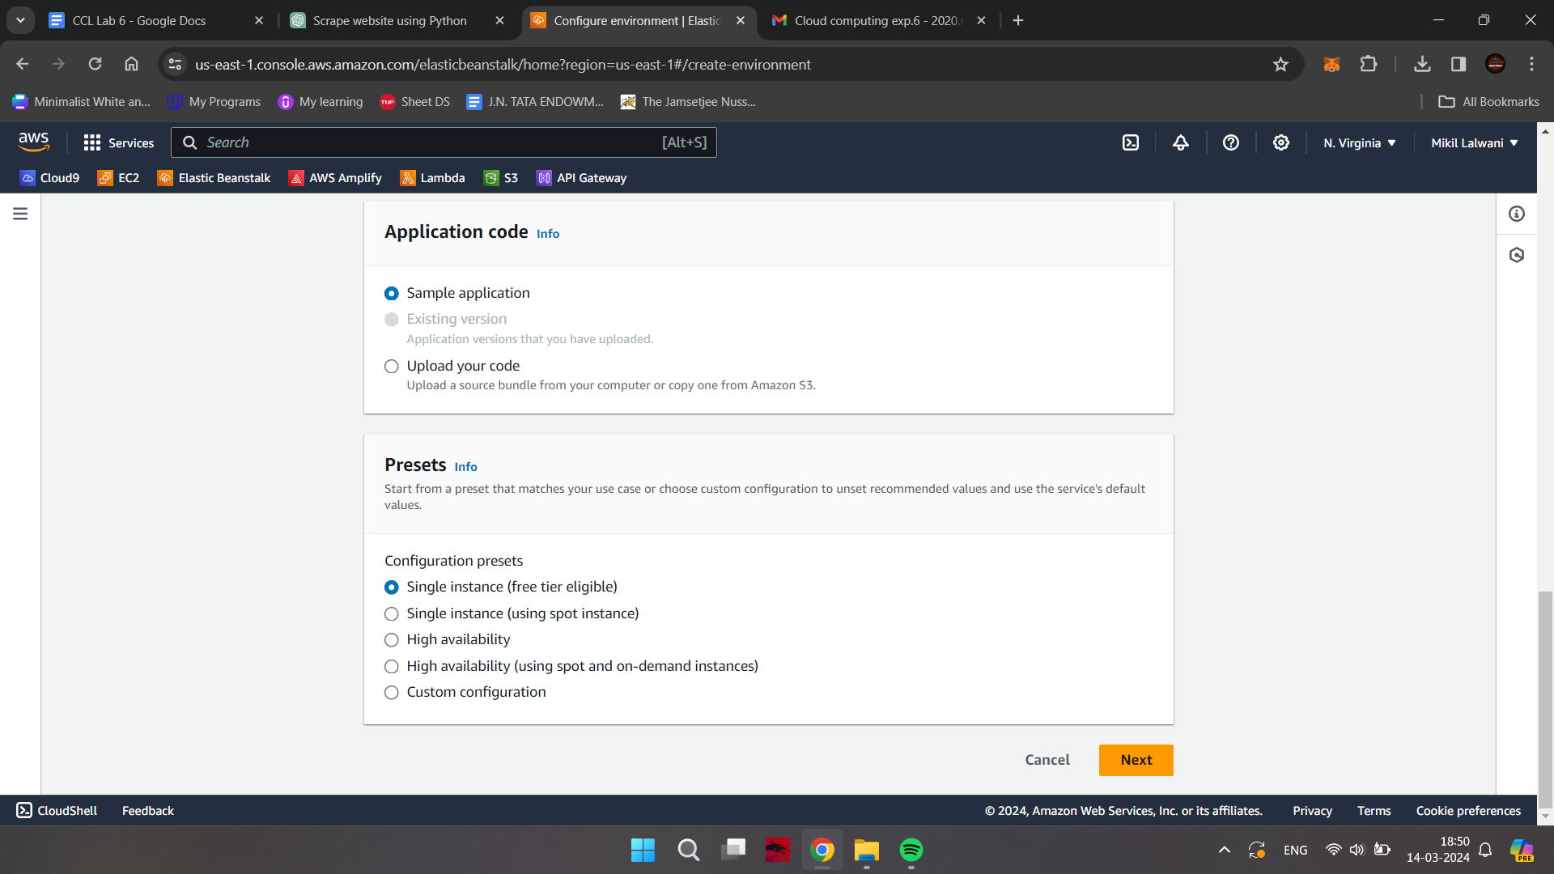

Step 5: Click on Environments -&gt; Check the health of Environment wait till it becomes ‘OK’

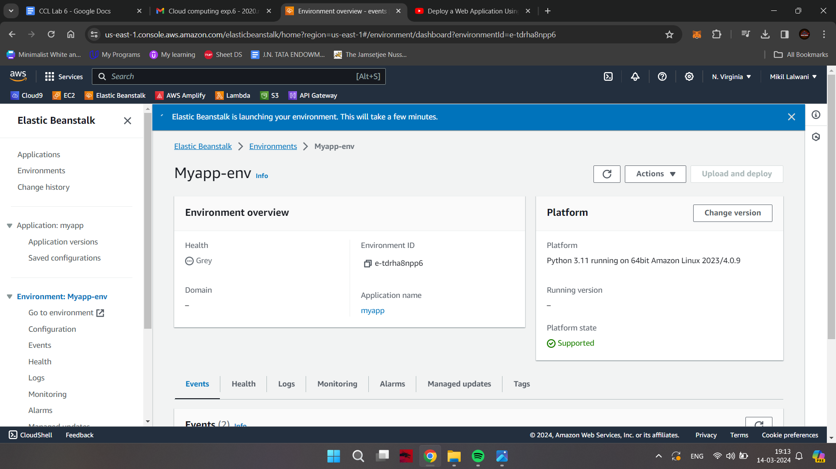

Step 6: Click the URL

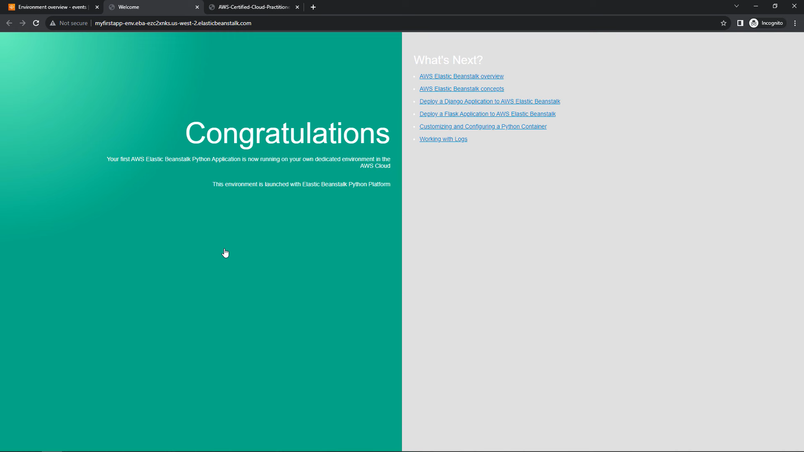

**Conclusion -**

Thus we have successfully learned about PaaS and implemented it on AWS Elastic Beanstalk Service.